**Nama : Ade Reiki Karuna  
NIM : A12.2020.06455  
Mata Kuliah : PBO**

**Tugas Praktik 3 (Operator dan Operand)**

**Latihan03a.java**

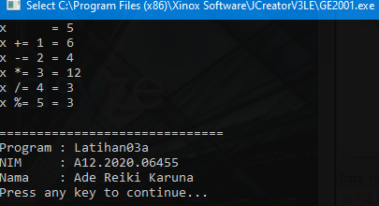

**Latihan03b.java**

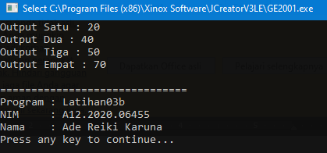

**Latihan03c.java**

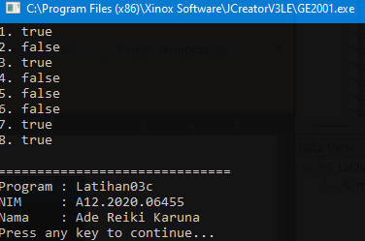

**Latihan03d.java**

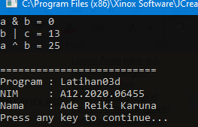

**Latihan03e.java**

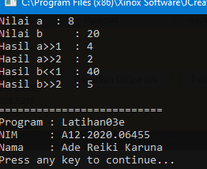

**Latihan03f.java**

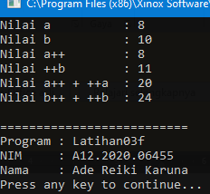

**Latihan03g.java**

